**Vishwamitra**

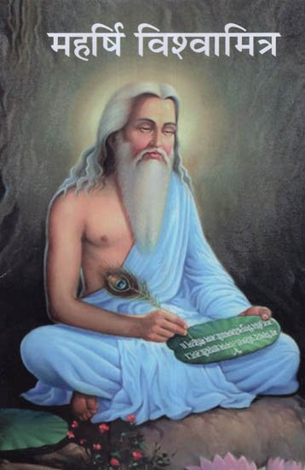

Brahmarshi Vishvamitra ("friend of the world") is one of the most venerated rishis or sages of ancient times in India. He is also credited as the author of most of Mandala 3 of the Rigveda, including the Gayatri Mantra. The Puranas mention that only 24 rishis since antiquity have understood the whole meaning of, and thus wielded the whole power of, the Gayatri Mantra. Vishvamitra is supposed to be the first and Yajnavalkya the last.

### Life and birth

The story of Vishvamitra is narrated in the Balakanda of Valmiki Ramayana.[1] The Mahabharata adds that Vishvamitra's relationship with Menaka resulted in a daughter, Shakuntala whose story is narrated in the Adi Parva of the Mahabharata.

Vishvamitra was a king in ancient India, also called Kaushika "descendant of Kusha". He was a valiant warrior and the great-grandson of a great king named Kusha. The Valmiki Ramayana, prose 51 of Bala Kanda, starts with the story of Vishvamitra:

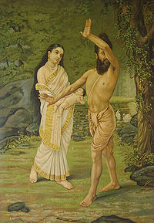There was a king named Kusha (not to be confused with Kusha, son of Rama), a brainchild of Prajapati, and Kusha's son was the powerful and verily righteous Kushanabha. One who is highly renowned by the name Gaadhi was the son of Kushanabha, and Gaadhi's son is this great-saint of great resplendence, Vishvamitra. Vishvamitra ruled the earth, and this great-resplendent king ruled the kingdom for many thousands of years.

His story also appears in various Puranas, however they show variations from the Ramayana. The Vishnu Purana and Harivamsha chapter 27 (dynasty of Amaavasu) of Mahabharatha narrates the birth of Vishvamitra. According to Vishnu Purana,[2] kushika married a damsel belonging to Purukutsa dynasty (later called as Shatamarshana lineage –

descendents of the Ikshvaku king Trasadasyu) and had a son by name Gaadhi who had a daughter named Satyavati (not to be confused with the Satyavati of Mahabharata).

Satyavati was married to an old Brahman known as Ruchika who was foremost among the race of Bhrigu. Ruchika desired a son having the qualities of a Brahman, and so he gave Satyavati a sacrificial offering (charu) which he had prepared to achieve this objective. He also gave Satyavati's mother another charu to make her conceive a son with the character of a Kshatriya at her request. But Satyavati's mother privately asked Satyavati to exchange her charu with her. This resulted in Satyavati's mother giving birth to Vishvamitra, the son of a Kshatriya Gadhi with the qualities of a Brahman; and Satyavati gave birth to Jamadagni, the father of Parashurama, a Brahman with qualities of a Kshatriya.

## **Conflict with Vashishta**

On one of his exploits, he and his soldiers took rest in the ashram of Rishi Vasistha. There, his whole army was well fed and taken care of. This caused a doubt in the king's mind as to how it was possible for this simple ashram to take care of all the arrangements to feed an entire army. He expressed his surprise to the sage. Vasistha replied,

"O king, this feast that you have partaken with your kinsmen, has been provided by my calf Nandini (sometimes referred as Sabala), who was gifted to me by Indra. You must know that she is the daughter of Indra's cow Kamadhenu. She provides me with everything I need."

Kaushika was filled with wonder when he heard this. He began to think that possessing this cow would mean a lot to him; after all, the sage did not have to provide food and sustenance for a large army everyday. He expressed a desire to the sage for obtaining Nandini from him. Vasistha was polite, but steadfast in his refusal. He would not be tempted by the offer of untold wealth that was made by Kaushika, for after all who can set a price on a cow, which can readily yield all the riches in the world.

The king grew exceedingly angry. He insulted the Brahmarishi with harsh words, and ordered his soldiers to seize the cow, and drive it to his kingdom. By his yogic powers, the great sage Vasistha, called forth an entire army of fierce warriors. They fought the army of Kaushika and defeated it thoroughly. Kaushika was captured and presented before Vasistha. The sage pardoned the king and sent him away with words of advice.

### Renunciation

This incident made a deep impression on the King. He realized that the power obtained by penances was far greater than mere physical might. He renounced his kingdom and began his quest to become a greater rishi than Vasistha. He took on the name Vishvamitra. It is very interesting to see all the challenges that Viswamitra faced in his life to become a Brahmarishi, before eventually giving up the greed to possess the cow. After many trials and undergoing many austerities, Vishvamitra at last obtained the title of Brahmarishi from Vasistha himself.

### Menaka and Vishvamitra

Menaka was born from the churning of the ocean by the Devas and the Asuras ([Samudra Manthan](https://vedicfeed.com/samudra-manthan-everything-to-know/)). She was the most beautiful, talented, and intelligent apsaras. She went on to become one of the prime apsaras in Lord Indra’s court. ([*Apsaras and Gandharvas*](https://vedicfeed.com/gandharvas-and-apsaras/))

Vishvamitra’s severe penance and his rapid climb in the spiritual realm frightened Indra and even tried to create another heaven. Indra then decided to send Menaka down to Earth to lure the rishi and distract him from his mediation. She successfully breaks the meditation of Vishvamitra. However, she fell in love with him and a baby girl was born called Shakuntala. He was later growing in Sage Kanva’s ashram and falls in love with King Dushyanta and gives birth to a child called [**Bharata**](https://vedicfeed.com/story-of-king-bharata/).

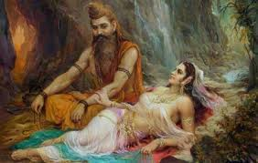

When Vishvamitra understood how he had been tricked by Indra, he flew into a rage. However, he loved Menaka deeply and also knew the true extent of her feelings for him. So he told her that she would be separated from him forever. Menaka was very proud of her youth and beauty.

**Rise to Brahmarishi**

After cursing Rambha, Kaushika goes to the highest mountain of the Himalayas to perform an even more severe tapasya for over a thousand years. He ceases to eat, and reduces his breathing to a bare minimum.

He is tested again by Indra, who comes as a poor Brahmin begging for food just as Kaushika is ready to break a fast of many years by eating some rice. Kaushika instantly gives his food away to Indra and resumes his meditation. Kaushika also finally masters his passions, refusing to be provoked by any of Indra's testing and seductive interferences. At the penultimate culmination of a multi-thousand year journey, Kaushika's yogic power is at a peak. At this point, Brahma, at the head of the Devas led by Indra, names Kaushika a brahmarishi, and names him Vishvamitra, or Friend of All for his unlimited compassion. He is also embraced by Vasistha, and their enmity is instantly ended.

**Gayatri Mantra**

Vishvamitra was the author of the revered great Mantra - The Gayatri Mantra. It is a mantra and a prayer found in the Rig, Yajur, and Sama Vedas. The Vedas clearly state that anyone can chant this Mantra, and gain its benefits. Gayatri Mantra:

Auṃ Bhur Bhuva Svah,

Tat Savitur Varenyam.

Bhargo Devasya Dhimahi

Dhiyo yo nah prachodayat

Meaning:

We meditate on the glory of the Creator;

Who is worthy of Worship,

Who is the source of knowledge,

Who is the bright light,

May he illuminate our intellect.

Gayatri Mantra is so called because it liberates one who chants it.

**Contributions of sage Vishvamitra :**

Vishvamitra is famous in many legendary stories and in different works of Sanatana dharma.

**Trisanku**

Another story Vishvamitra is known for is his creation of his own version of Svarga or heaven, called Trisanku Svarga. When a proud King Trisanku asked his guru, Vasistha, to send him to heaven in his own body, the guru responded that the body cannot ascend to heaven.

King Trisanku then asked Vasistha's hundred sons to send him to heaven. The sons, outraged that Trisanku should not come to them when their father had refused, cursed him to be a Chandala, or untouchable. Trisanku was transformed into a person with body smeared of ash, clothed in black and wearing Iron jewellery. Since none of his subjects could recognize him, he was driven out of the kingdom.

He came across the sage Vishvamitra, who agreed to help him. Visvamitra organized a great sacrifice and ritual proptiating the Devas, pleading that they accept Trisanku in heaven. Not one Deva responded. Angered, Viswamitra used his yogic powers and ordered Trisanku to rise to heaven. Miraculously, Trisanku rose into the sky until he reached heaven, where he was pushed back down by Indra.

Enraged even more by this, the powerful Visvamitra then commenced the creation of another heaven for Trisanku. He had only completed the heaven when Brihaspati ordered him to stop. Trisanku, however, did not enjoy Trisanku Svarga, he remained fixed in the sky and was transformed into a constellation.In the process of forming a new universe, Vishvamitra used up all the tapas he had gained from his austerities. Therefore after the Trisanku episode, Vishvamitra had to start his prayers again to attain the status of a Brahma Rishi, to equal Vashistha.

**Harishchandra's Sacrifice**

While undertaking a penance, Kaushika helps a boy named Shunashepa who has been sold by his parents to be sacrificed at Harishchandra's yagna to please Varuna, the God of the Oceans. The king's son Rohit does not want to be the one sacrificed, as was originally promised to Varuna, so young Sunashep is being taken. A devastated and terrified Sunashepa falls at the feet of Kaushika, who is deep in meditation, and begs for his help.

Kaushika teaches secret mantras to Sunashepa. The boy sings these mantras at the ceremony, and is blessed by Indra and Varuna, and Harishchandra's ceremony is also completed.

**In the Ramayana**

Vishvamitra looks as Rama breaks the bow, winning the hand of Sita in marriage. Painting by Raja Ravi Varma.

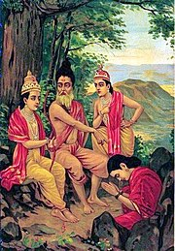In the Indian epic Ramayana, Vishvamitra is the preceptor of Rama, prince of Ayodhya and the seventh Avatar of Vishnu, and his brother Lakshmana.

Vishvamitra gives them the knowledge of the Devastras or celestial weaponry [bala and adi bala], trains them in advanced religion and guides them to kill powerful demons like Tataka, Maricha and Subahu. He also leads them to the svayamvara ceremony for princess Sita, who becomes the wife of Rama.